**IT5613 - SOCIALLY RELEVANT PROJECT LABORATORY**

**GLOBAL SYSTEM OF HUB FOR CULTURE**

**AND HERITAGE PRESERVATION**

**BATCH-1**

**TEAM-10**

**TEAM MEMBERS :**

**ABINAYA V - 2021506003**

**ELAKIYA I - 2021506021**

**ELLAMMAL MA - 2021506022**

**JANANI A - 2021506030**

**User Interface Design**

Explore our esteemed platform committed to the preservation of culture and heritage. Access a wealth of resources, including insightful articles, innovative projects, and invaluable guidance aimed at safeguarding our cherished traditions. Join us in our mission to celebrate and perpetuate our collective history, ensuring its enduring legacy for future generations. Together, let us champion the preservation of our cultural heritage with unwavering dedication and resolve.

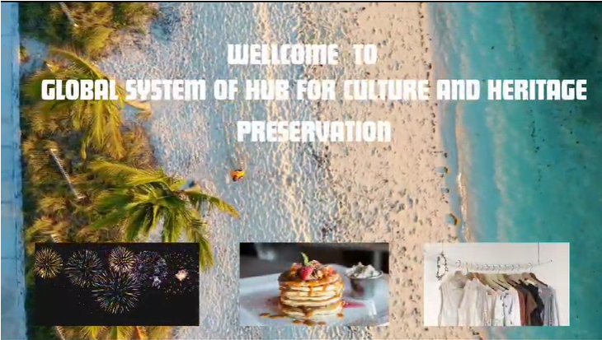

# User Information:

# Enhance your engagement with our platform dedicated to culture and heritage preservation through our user-friendly login process. Sign up and effortlessly access your account with a unique 4-digit code, ensuring swift and secure login experiences. Enjoy seamless return visits by using the same code. Join us in safeguarding our cultural legacies with ease.

# 

# GLOBAL CONNECTION:

# Join our global community preserving culture and heritage. Access resources, engage in discussions, and collaborate across borders. Let's safeguard our shared traditions for the future.

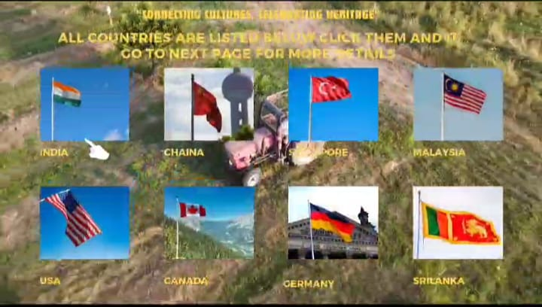

# Navigation pages:

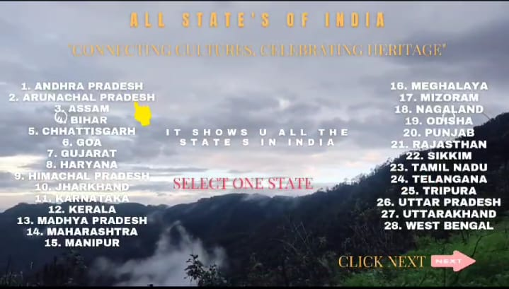

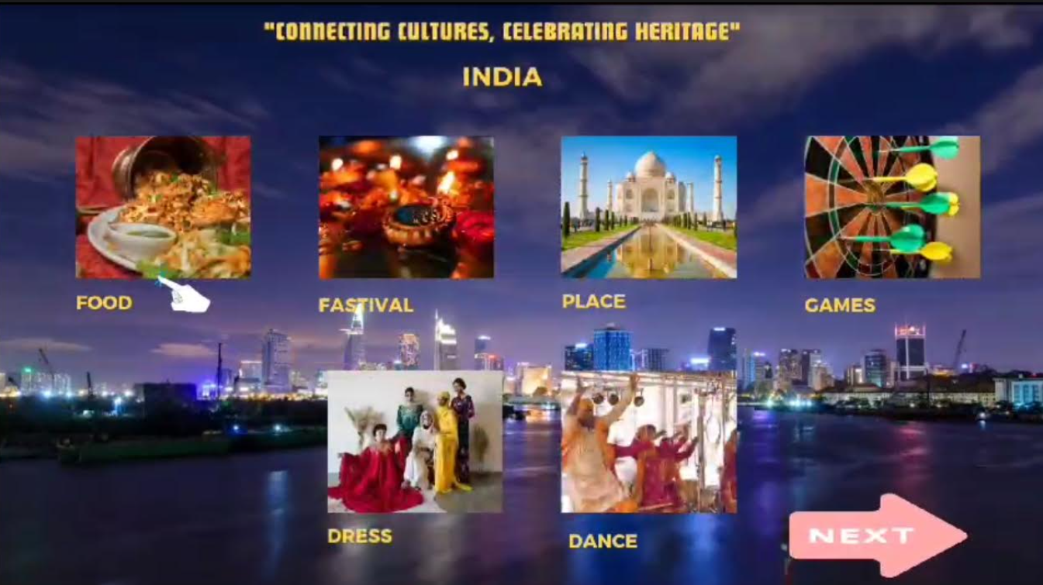

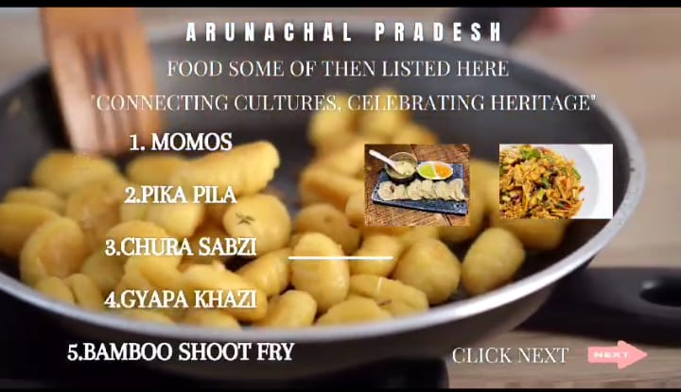

# Feedback Mechanism:

